This is a direct continuation of the previous page. We will be using the Node.js project to learn how to create an HTTP server. This will be utilizing both the app.js and run.bat files previously created. (no new files are necessary) **How to create an HTTP server:**

1. In the app.js file, create one new variable - http and use the “require” method. This is known as the built-in HTTP module.
2. 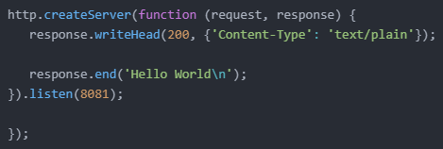With this new variable, use the createServer method. (This will be what allows the server to listen to the port and send a response back)
3. Use “writeHead()” and “end()” to set the response content.
4. The “createServer” function will run when the specified port, 8081, is accessed.
5. Use the console.log command to ensure your code is running as intended.
6. In the run.bat file, change “npm init” into “node app.js”.
7. Run the .bat file. If it functions correctly you should see this in the console and “Hello World” when you navigate to http://127.0.0.1:8081/.